**GEOS3102: Global Energy & Resources Labs**

Dietmar Muller, Tristan Salles, Amy I’Anson

Lab Overview

|  |  |  |  |  |
| --- | --- | --- | --- | --- |
|  | **Exercises** | **Weight** | **Due Date** | **Submission** |
| Lab 1 (Week 8) | Intro to Global Petroleum Resources and iPython | 10% | Thursday May 11 @ 9am | Madsen Dropbox |
| Lab 2  (Week 9) | Badlands | 15% | Thursday May 18 @ 9am | Madsen Dropbox |
| Lab 3 (Week 10) | Seismic Reflection Surveys | 15% | Thursday May 25 @ 9am | Madsen Dropbox |
| Lab 4 (Week 11) | Well Log Analysis | 15% | Thursday June 1 @ 9am | Madsen Dropbox |
| Lab 5  (Week 12) | Arafura Basin Petroleum Systems | 15% | Thursday June 8 @ 9am | Madsen Dropbox |
| Lab 6  (Week 13) | Tectonic Subsidence and Arafura Basin Report | 30% | Thursday June 15 @ 9am | Email [amy.ianson@sydney.edu.au](mailto:amy.ianson@sydney.edu.au) |

Each week a paper copy of the exercise will be provided for you. Please write neatly and clearly, messy and illegible reports will not be marked. You are also welcome to complete the exercise in the pdf available online. Remember to attach relevant maps and data.

Exercises are shown in grey boxes, answer in the space provided or attach your answer to the lab sheet.

**Your assignment is due Thursday the following week at 9am! 10% will be deducted per day late.**

Please note: You do not need to include your script for iPython practicals unless a question states “**Include your script”** in which case you only need to include the relevant portion of your script (please do not waste paper and print the entire script).

Lab 5: Arafura Basin Project

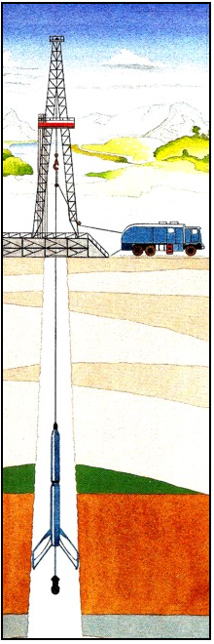For the remainder of the labs we will be investigating the Arafura Basin in the Northern Territory. In the final week you will be required to draw upon lab 5/6 in a report on the Arafura Basin.

The Arafura Basin is located on the northern margin of Australia in the Arafura Sea and extends from the onshore Northern Territory to offshore northern Australia and beyond the Australian-Indonesian border, covering approximately 200 000km2 in Australian territory.

The Arafura Basin is underexplored, and we know very little about it, only 9 wells being drilled in the 10km of sediment – it is also very old! There have been oil and gas shows but no discoveries (yet?). The Neoproterozoic to Palaeozoic Arafura Basin is underlain by the Proterozoic McArthur Basin and the Archean to Proterozoic Pine Creek Inlier, and overlain by the Mesozoic to Recent Money Shoal Basin. The structure of the Arafura Basin is dominated by the highly deformed Goulburn Graben.

The Goulburn Graben is a northwest trending asymmetric feature, over 350km long and up to 70km wide, and contains a sedimentary section in excess of 10km thick (GA, 2012).

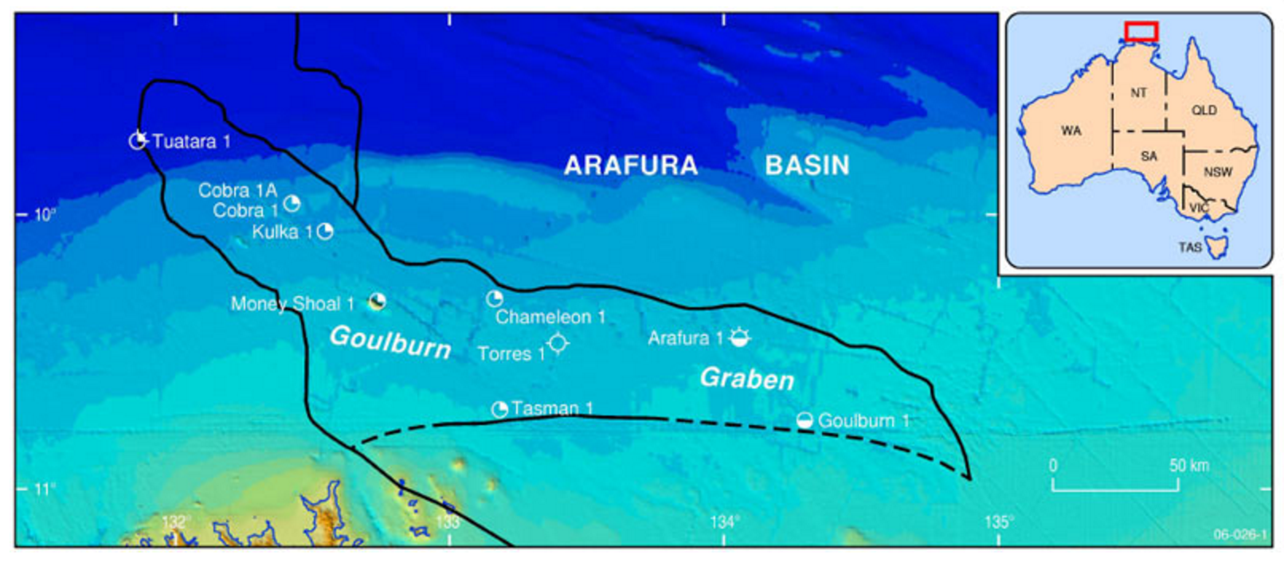

Petroleum Systems Background Information

The petroleum system is a unifying concept that encompasses all of the elements and processes of petroleum geology, including: the essential elements (source, reservoir, seal, and overburden rock) and processes (trap formation, generation-migration-accumulation). We generally analyse petroleum systems in the following subcategories;

**Source** **(consider quantity & quality, maturity, migration, evidence of presence)**

In petroleum geology, source rock refers to rocks from which hydrocarbons have been generated or are capable of being generated. They form one of the necessary elements of a working petroleum system. They are organic-rich sediments that may have been deposited in a variety of environments including deep water marine, lacustrine and deltaic.

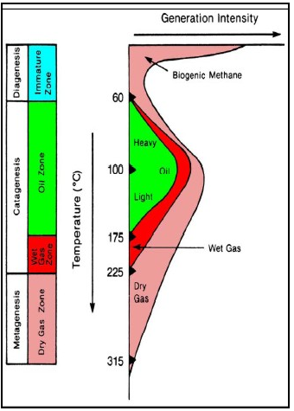To evaluate source rock potential we use organic chemistry of the source rock;

* Source Richness and Quality Measures
  + The total organic carbon (TOC) content of rocks is obtained by heating the rock in a furnace and combusting the organic matter to carbon dioxide
  + The S2 yield in the lab is the amount of hydrocarbons generated through thermal cracking (mg/g) – provides the quantity of hydrocarbons that the rock has the potential to produce through diagenesis
  + Calculated results include the Hydrogen index. HI = 100(S2) / TOC%
* Source Maturity – The hydrocarbon potential of organic carbon depends on the thermal history of the rocks containing the kerogen. Both temperature and the time at that temperature determine the outcome. Medium temperatures (< 175 C) produce mostly oil and a little gas. Warmer temperatures produce mostly gas. (right)

**Reservoir (where we consider thickness, porosity, permeability)**

We need to determine if the reservoir can hold hydrocarbons, to do this, we take both indirect and direct measurements of porosity and permeability, informed by an interpretation of depositional environment.

**Traps and Seals**

A trap forms when the buoyancy forces driving the upward migration of hydrocarbons through a permeable rock cannot overcome the capillary forces of a sealing medium. The timing of trap formation relative to that of petroleum generation and migration is crucial to ensuring a reservoir can form.

Petroleum geologists broadly classify traps into three categories that are based on their geological characteristics: the structural trap, the stratigraphic trap and the far less common hydrodynamic trap. The trapping mechanisms for many petroleum reservoirs have characteristics from several categories and can be known as a combination trap.

Structural traps = Fold (structural) trap and Fault (structural) trap

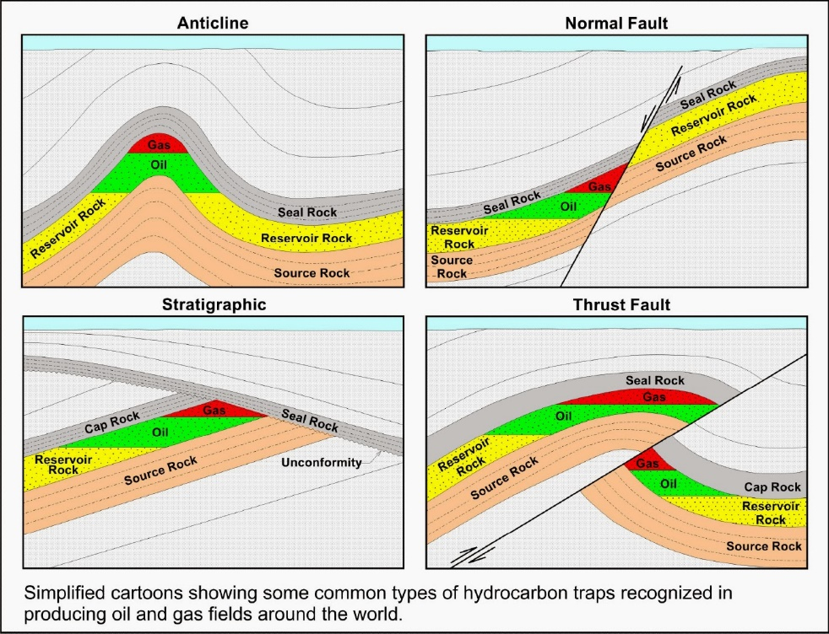Structural traps are formed as a result of changes in the structure of the subsurface due to processes such as folding and faulting, leading to the formation of domes, anticlines, and folds. Examples of this kind of trap are an anticline trap, a fault trap and a salt dome trap.

They are more easily delineated and more prospective than their stratigraphic counterparts, with the majority of the world's petroleum reserves being found in structural traps.

Stratigraphic traps

Stratigraphic traps are formed as a result of lateral and vertical variations in the thickness, texture, porosity or lithology of the reservoir rock. Examples of this type of trap are an unconformity trap, a lens trap and a reef trap.

Seals

The seal is a fundamental part of the trap that prevents hydrocarbons from further upward migration.

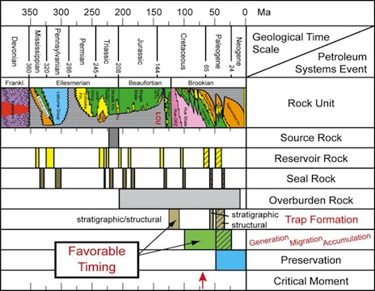**Accumulation/Timing (preservation of hydrocarbons)**

All of this needs to happen in the right order!

The expulsion of oil in the Goulburn Graben occurred in the Late Devonian and Carboniferous.

We are going to consider each of these remaining petroleum systems elements for the Arafura Basin. You may want to spend some time investigating the OrgChem and ResFacs from the GA database for the remainder of the wells, this will help you write a comprehensive report in Week 6. It is useful practice to label your basemap with the different parameters to get a sense of the spatial distribution of source/reservoir facies.

Lab 5 Exercises

NAME: _________________________________ SID: ________________________________

Q1. Using the interpretation from Kulka-1, interpret the stratigraphy at Chameleon-1.

Q2. Using the interpretation from Cobra-1A, interpret the stratigraphy at Tuatara-1.

Q3. Familiarise yourself with the remaining wells. Note where the oil shows and flows are. How are the shows and flows distributed stratigraphically?

____________________________________________________________________________________________________________________________________________________________________________________________________________________________________________________________

Q4. How is the stratigraphy distributed spatially? Do you notice any trends in the occurrence of oil shows? Summarise this information on the base map below.

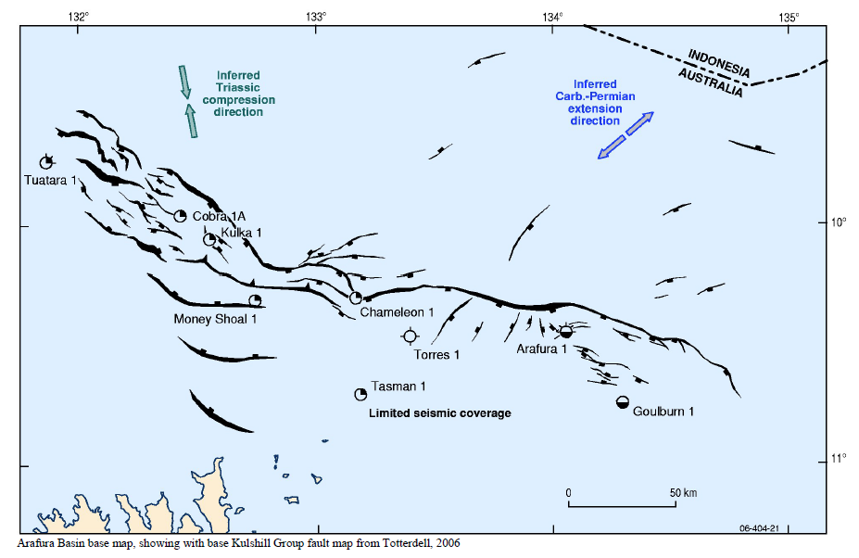

Q5. Using the Geoscience Australia database <http://dbforms.ga.gov.au/www/npm.well.search> characterise the source potential of any two wells in the Arafura Basin in terms of Source Richness and Quality/Maturity.

________________________________________________________________________________________________________________________________________________________________________________________________________________________________________________________________________________________________________________________________________________________________________________________________________________________________________________________________________________________________________________________

Q2. Reservoir – Using your well logs and the GA database, characterise the reservoir facies for two wells of the Arafura Basin.

____________________________________________________________________________________________________________________________________________________________________________________________________________________________________________________________________________________________________________________________________________________________________________________________________________________________________

Q3. Traps – Looking at the seismic cross sections for Kulka 1 and Tasman 1, what type of trap was being chased in each? Label them.

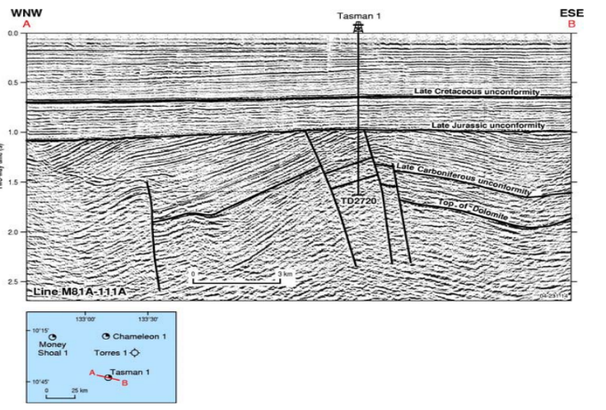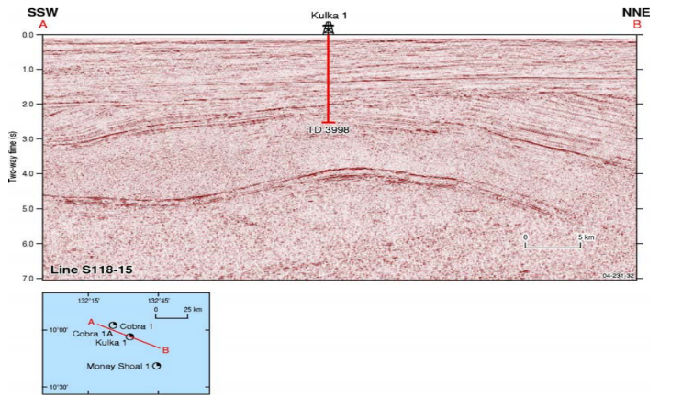

Additional Information

